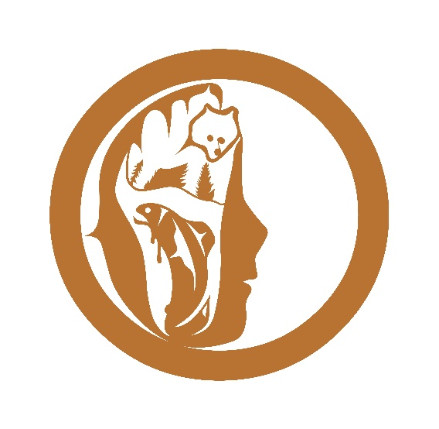
nunumus management limited
PO Box 852
Bella Coola, BC V0T 1C0
(250) 799-0033

BACKGROUND INFORMATION

Nuxalk Nation Traditional Territory is situated on the Central Coast region of BC. Before European contact, there were several Nuxalk village sites situated in various geographic sub-regions of the Nation. For a variety of historical reasons, the outlying villages were invited to relocate to the present site. The current population of the Nuxalk Nation resides primarily on the Bella Coola Reserve, including two built up areas: a community adjacent to the non-Nuxalk town of Bella Coola, (“Downtown”) and the main residential community (“Four Mile”). Other significant populations of Nuxalk members reside in Williams Lake, Kamloops, and the lower mainland region.

The geographic region is characterized as rural remote, approximately 400 miles northwest of Vancouver, and consists of coastal mountains, valleys, and several fiords of the Pacific Ocean. There is a provincial public highway providing access to the interior region and beyond, provincial ferry service, and a municipal airport with daily scheduled passenger service to Vancouver. The Central Coast Regional District municipality is co-located in the Bella Coola Valley, with overlapping jurisdictional boundaries to the Nuxalk Nation. Current population estimates place the Nuxalk population at approximately half the total population within the area.

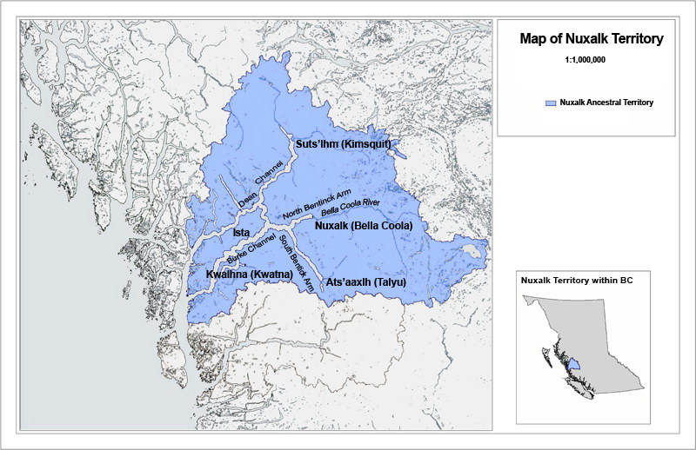

Governance is provided by a dual system – the Hereditary Chiefs (“Stataltmc”) are the recognized heads of the family units, which trace their lineage to the original village sites and the surrounding geographic areas. The Stataltmc provide moral guidance and are responsible for stewardship of the land; and the Chief and Council, elected under the Indian Affairs process with 2 year electoral terms. The Nation’s administrative affairs are overseen by Chief and Council using a portfolio system.

Nunumus management limited (“NML”) is the new name of the Nuxalk Development Corporation. NML is the Economic Development Corporation of the Nuxalk First Nation. The trustees, appointed by Chief and Council, hold shares in trust for the elected Nuxalk Nation Chief and Council, and are responsible for selecting, and monitoring the performance of, the independent Board of Directors. The Board of Directors are independent of the elected Nuxalk Nation Chief and Council, and manage the operations of the group of NML subsidiary enterprises (“the NML Group”). A majority of 4 of the 5 Directors are Nuxalk members, but all have been selected for their background and experience in business. They exercise their management oversight through hiring and monitoring the performance of the Chief Executive Officer, who in turn is responsible for hiring and monitoring the performance of the managers of each enterprise, and their respective operations staff. A current Organization Chart has been included below.

The NML Group is a diversified portfolio of stand-alone business enterprises. Nunumus management limited serves as the Head Office and provides management oversight to the activities of the entire group. We utilize the Limited Partnership model to allow for the independent operation of business units, and the isolation of any business risk so that the overall group or the Nation’s assets are not put at undue risk. At the present time, in addition to the Head Office function, we operate Nuxalk Forestry Limited Partnership (logging operations), NDC Essential Oils Limited Partnership (manufacture and distribution of essential oil extracts), Totem Sawmill Limited Partnership (dimensional lumber mill), Nuxalk Commercial Fisheries Limited Partnership (leasing Nation owned licences and quota to First Nations fishers), Nuxalk Development Limited Partnership (General Partner of LP’s plus Copper Sun tourism ventures), and our newest venture is NML Contracting Limited Partnership (labour and services contracting and supply). We are also exploring several other business projects that may become operating subsidiary enterprises in the future as we continue to grow.

